How to make github.io website
Multiple ways to do this (i.e. all through terminal, all through github website), but this is one that worked for me.
- New repository, called username.github.io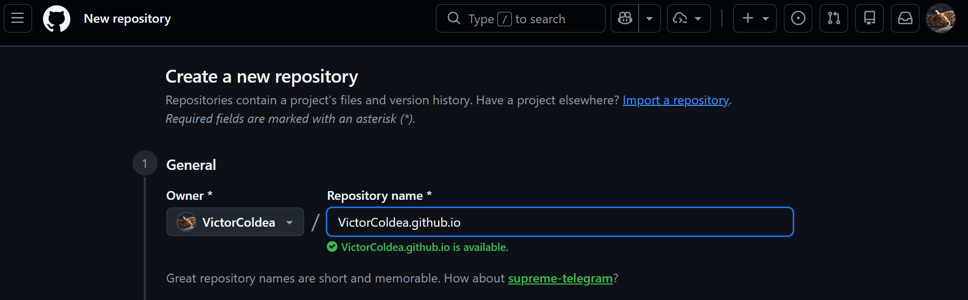
- Create folder on computer containing files for the website.

